JBT Template
Polarity Reversion of the Operation Mode of HfO₂-Based Resistive Random Access Memory Devices by Inserting Hf Metal Layer

Ching-Shiang Peng,^{a,z}Wen-Yuan Chang,^{b,z}Ming-Ho Lin,ª Wei-Su Chen,^{c}
Frederick Chen,^{c} and Ming-Jinn Tsai^{c,*}
ªDepartment of Materials Science and Engineering, National Tsing-Hua University, Hsinchu 300, Taiwan
^{b}Institute of Photonics and Optoelectronics, National Taiwan University, Taipei 106, Taiwan
^{c}Electronics and Optoelectronics Research Laboratory, Industrial Technology Research Institute, Chutung,

Hsinchu 310, Taiwan

*Corresponding authorEmail:…………………………
Insert Submission Date Here

Submitted/Received: ……....……………..…Accepted: …………....…………...

The reversion of polarity within bipolar resistive switching operation occurs in Pt/HfO₂/TiN and Pt/Hf/HfO₂/TiN resistive random access memory devices. This reversion of voltage polarity is the result of interface generation which induces a conduction mechanism transformation from Poole-Frenkel emission to space charge limited current mechanism. To provethe reversion of polarity, this study uses curve fitting of I-V relations to verify the conduction mechanism theoretically and physical analysis to verify the oxygen ion distribution practically. The proposed Pt/Hf/HfO₂/TiN devices exhibit good resistive switching characteristics, such as good uniformity, low voltage operation, robust endurance (10³ dc sweep), and long retention (3×10⁴ s at 85 ºC).
Keywords:HfO₂, Resistive random access memory, Hf Metal Layer, polarity reversal.

- Introduction
Resistive random access memory (RRAM) is an ideal candidate for non-volatile memory applications because of its simple structure, great scalability, fast switching speed, low power consumption, and compatibility with complementarymetal-oxide semiconductor technology.1^{,2} RRAM devices achieve the memory effect using the switchable resistance transformation between a high resistance state (HRS) and a low resistance state (LRS), and typically consist of a metal/insulator/metal structure. RRAM devices generally have two switching modes (unipolar and bipolar), which alternate based on the operating voltage polarity. Unipolar resistive switching occurs in any single voltage bias and does not depend on voltage polarity. Conversely, bipolar resistive switching depends on the variation of voltage polarity to complete the set (i.e., from the HRS to the LRS) and reset (i.e., from the LRS to the HRS) processes. Recent developments in RRAM have shifted to bipolar RRAM for several advantages, including a stable ON/OFF ratio, robust endurance, good retention, smaller switching voltage fluctuation, and the one selector-one resistor (1S1R) application.3The transition metal oxide, HfO₂, is already widely used in semiconductor industries because of its superior physical properties, such as large permittivity, subsequent band gap, and excellent thermal stability.4 In addition to its use as high-k/metal gate stacks, HfO₂-based RRAM has attracted significant attention for its potential in next-generation nonvolatile memory.HfO₂-based RRAM devices are formed by an electric-field induced conductive filaments formation/rupture process, and possess superior bipolar resistive switching for future RRAM applications.
The localized filamentary conducting paths in the thin films are diverse in each switching, leading to the nonuniform distributions of switching voltages and resistance states, which result in irresolvable errors in the RRAM operations. Thus, how to effectively improve the stability of switching behavior is an essential issue for practical application of the RRAM.Researchers have used many methods to improve resistive switching characteristics and change thin-film properties, such as embedding nanocrystals,⁵doping effects,6,7and embedding metal layer.8⁻¹¹The embedding metal layermethod typically serves as an interfacial oxygen storage layer, leading to oxygen ion concentration variation and diffusion. This in turn confines the conductive filament formation and rupturing within insulators and improves the uniformity of resistive switching characteristics. The interfacial layer also play a key role in polarity effect and resistive switching, and is dominant inthe conversion of polarity from unipolar resistive switching to bipolar resistive switching, as shown by Yoo et al.¹² The reversion of polarity within bipolar resistive switching operation in Pt/HfO₂/TiN and Pt/Hf/HfO₂/TiN devices was observed in this work.The polarity reversion may be significantly affected by interfacial layer generation, inducing the change of conduction mechanisms in two device structures. The I-V relation and physical analysis in this study both provide proofs of the reversion of polarity. Pt/Hf/HfO₂/TiN RRAM devices also exhibit good resistive switching characteristics by inserting Hf metal layer resulted in the production of HfO_{x} layer as an oxygen storage layer.

- Experimental Details
In this study, RRAM devices consist of Pt/HfO₂/TiN and Pt/Hf/HfO₂/TiN structures. HfO₂ thin films were deposited on TiN (50 nm)/Ti (150 nm)/SiO₂ (200 nm)/p-Si substrates at 200 ºC using the atomic layer deposition (ALD) method. The HfO₂ thin film (derived from TEMAH and H₂O precursors) was controlled at approximately 10 nm, and the deposition thickness of HfO₂ per ALD cycle was approximately 0.1 nm. After HfO₂ thin-film deposition, Hf and Pt metal layers measuring 40 nm and 70 nm in thickness were capped continuously by dc sputtering and patterned by a shadow mask with a diameter of 200 μm. The Pt capping layer prevents oxygen penetration from the atmosphere. The Pt/Hf/HfO₂/TiN device was subjected to post metal annealing (PMA) at 400 ºC for 30 s in a N₂ atmosphere.For a comparison, a reference sample made without Hf layer and PMA process was also prepared, denoted as Pt/HfO₂/TiN device.The chemical-bonding states of Hf atoms in thin films were analyzed using the X-ray photoelectron emission spectrum (XPS). The electrical properties of the devices were measured using a Keithley 4200 semiconductor parameter analyzer. During the voltage-sweeping mode measurement, the bias was defined as positive when the current flowed from the top electrode to the bottom electrode, and was defined as negative when the current flowed in the opposite direction.

3. Results and Discussion
Figures 1a and 1b show the reverse polarity operation within bipolar resistive switching. Figure 1a shows that the set operation by a negative bias and the reset operation by a positive bias appear in the electrical characteristics of Pt/HfO₂/TiN RRAM devices. The same polarity was observed in similar devices described in previous researches.^{13,14} After the Hf metal layer deposition and PMA processes, Pt/Hf/HfO₂/TiN RRAM devices show reverse polarity operation (i.e., the set operation by a positive bias, and the reset operation by a negative bias) in a stable resistive switching situation, as shown in Fig. 1b. The experimental results and literatures review in this study will confirm that the reverse polarity is correlated with interface-producing and conduction mechanism, transforming between two structures. In Pt/HfO₂/TiN RRAM devices, the conduction mechanism in pure HfO₂ thin films is usually attributed to the Poole-Frenkel emission.^{15,16} The Poole-Frenkel emission equation can be expressed as $J=\left(qN_{c}μ\right)Eexp 〔-\frac{qΦt}{kT}+\frac{q\sqrt{qE/πε_{γ}ε_{0}}}{rkT}〕$, in which q is the electronic charge, $N_{c}$ is the density of states in the conduction band, μ is the electronic drift mobility, qΦt is the trap level below the conduction band, ε_{γ} is the dynamic dielectric constant, ε_{o} is the permittivity of free space, k is Boltzmann’s constant, T is the temperature, and r is a coefficient ranging between 1 and 2.^{17,18} If r = 2, the conduction mechanism is so-called the normal Poole-Frenkel emission. However, when the insulator contains another influential trap, r is equal to 1 and the conduction is called the modified Poole-Frenkel emission. In the reset process, the$㏑\left(J/E\right)-\sqrt{E}$ relationship of the HRS in the high electric field exhibits linear dependence, as shown in Fig. 2a. Accordingly, a refractive index of n = 2.05 can be obtained from the slope of the Poole-Frenkel plot at r = 1. This value is close to that of HfO₂ thin films reported in previous studies.^{19,20} The consistency between these results and fitting data implies that Poole-Frenkel emission is the primary conduction mechanism in Pt/HfO₂/TiN RRAM devices.
Voltage polarity during resistive switching operation in the Pt/HfO₂/TiN RRAM device can be reversed by Hf metal deposition and the PMA process. This study applies theoretical deduction and physical analysis to investigate the reason for this polarity reversion. Initially, curve fitting was executed for the negative bias region of I-V characteristics in the Pt/Hf/HfO₂/TiN RRAM device. Figure 2b shows the resulting double-logarithmic plots. In the reset operation, Child’s square law (I~V²) is obeyed in the high-voltage bias by slope ~ 2 in the HRS, whereas Ohm’s law (I~V) is obeyed in the low-voltage bias by slope ~ 1 in the HRS. According to the fitting results, the conduction mechanism of the proposed Pt/Hf/HfO₂/TiN RRAM devices is caused by space charge limited current (SCLC) mechanism.9^{,16,21} Many studies have indicated that the SCLC mechanism is related to the insulating interfacial layer formation between metal layers and oxide thin films. This suggests the presence of an oxide interfacial layer between the Hf metal and the HfO₂ thin film, which might be partial oxide HfO_{x} (x<2).9^{,16,21}After the PMA process, many oxygen ions may diffuse from the HfO₂ thin film to the Hf metal, resulting in the formation of HfO_{x} with oxygen deficiencies and Hf oxidation. To verify upon deductions of Pt/HfO₂/TiN and Pt/Hf/HfO₂/TiN RRAM devices, XPS analysis was adopted to characterize the distribution of oxygen. The XPS data, which were obtained at a fixed sputtering rate, shows localization near the interface. Figures 3a and 3b show the XPS spectra of the Hf 4f core levels of the pure HfO₂ thin film and the Hf/HfO₂ structure. Figure 3a shows that the Hf 4f core level correlates with the pure HfO₂ thin film. However, the Hf 4f region in the Hf/HfO₂ structure correlates with three spin-orbit doublets, each with corresponding 4f_{7/2} binding energies at 14.21, 15.4, and 18.26 eV.²² The pink, green and red lines in this figure represent the Hf metal (Hfº), the suboxide (HfO_{x}) and the fully oxidized hafnium (HfO₂) signals, respectively. These XPS results confirm the presence of an interfacial layer between the Hf metal and the HfO₂ thin film. Based on these results, the Pt/Hf/HfO₂/TiN RRAM device with an interfacial layer between the Hf layer and the HfO₂ thin film was dominated by the SCLC conduction mechanism. The polarity reversion of resistive switching behaviors can be explained by the effect of the interfacial layer, which fixes the oxygen diffusion region in the upper interface. The Pt/HfO₂/TiN devices did not exhibit this phenomenon. Figure 4 shows the possible switching mechanism with different directions of applied bias. In virgin Pt/Hf/HfO₂/TiN devices after PMA (Fig. 4a), the oxygen storage layer getters oxygen ions and leaves charged oxygen vacancies in the oxide thin film, which makes the oxide thin film oxygen-deficient and conductive. Because the HfO₂ thin film becomes more conductive, a smaller-forming voltage (~1 V) can be applied to connect filaments formed by oxygen vacancies. When applying a positive bias to the top electrode (Fig. 4b), the external voltage enforces charged oxygen vacancies to form a conductive filament. This subsequently switches the device to the LRS. After applying a negative bias to the top electrode (Fig. 4c), the oxygen ions drift to the HfO₂ thin film from the interfacial layer and reoxidize the conductive filament, rupturing the filaments. This subsequently switches the device to the HRS. Figures 5a and 5b show a comparison of the uniformity parameters of the two devices based on cumulative probability statistics. The Pt/Hf/HfO₂/TiN RRAM devices exhibit more uniform resistive switching performance than Pt/HfO₂/TiN RRAM devices in both resistance and voltage distributions. The low operation voltages (lower than 1 V) in the Pt/Hf/HfO₂/TiN device, reveals the potential for low-power RRAM applications. The Pt/Hf/HfO₂/TiN devices also exhibit excellent resistive switching properties in both the endurance and retention test. After a 10³ dc sweep, the HRS and LRS maintain a stable resistance ratio higher than ten without decay, as shown in Fig. 6a. The dispersion of operation voltages demonstrates the high switching uniformity, as shown in Fig. 6b.Figure 6c shows their good data storage ability (3×10⁴ s) under 100 mV stress at 85 ºC with nondestructive read-out.
- Conclusion
In conclusion, this study shows that inserting a Hf metal layer into a Pt/HfO₂/TiN device and subjecting it to a PMA process creates a Pt/Hf/HfO₂/TiN device that exhibits polarity reversion in the resistive switching property. Inserting a Hf metal layer and performing the PMA process activated the Hf metal layer as an oxygen storage layer, which makes redox fixed near the interface between the Hf metal and the HfO₂ thin film. Consequently, the interface generation (HfO_{x}) that makes the conduction mechanism switch to SCLC mechanism from Poole-Frenkel emission, leading to a polarity reversion. The proposed Pt/Hf/HfO₂/TiN devices also exhibited good resistive switching characteristics and switching uniformity, with a low-voltage operation, 10³ dc sweep endurance, and 3×10⁴ s retention test at 85 ºC.

Acknowledgments
The authors would like to express heartfelt thanks to the Prof. S.-J. Lin and the late Prof. T.-B. Wu from National Tsing-Hua University. C.-S. Peng is grateful to Dr. D.-T. Lee and G.H. Group for their helpful discussions. We also appreciate the Industrial Technology Research Institute of Taiwan (under Contract A351AA5110)and National Science Council of Taiwan (under Contract NSC 101-2120-M-007-003) for providing financial support.

Follow JNN ReferenceEXAMPLE;

References and Notes
1. I.G. Baek, M. S. Lee, S. Seo, M. J. Lee, D. H. Seo, D.-S. Suh, J. C. Park, S.O. Park, H. S. Kim, I. K. Yoo, U-In Chung, and J. T. Moon, Tech. Dig.- Int. Electron Devices Meet. 587 (2004).
2. H.-Y. Lee, Y.-S. Chen, P.-S. Chen, P.-Y. Gu, Y.-Y. Hsu, S.-M. Wang, W.-H. Liu, C.-H. Tsai, S.-S. Sheu, P.-C. Chiang, W.-P. Lin, C.-H. Lin, W.-S. Chen, F.-T. Chen, C.-H. Lien, and M.-J. Tsai, Tech. Dig. Int. Electron Devices Meet. 460 (2010).
3. J.-J. Huang, Y.-M. Tseng, C.-W. Hsu, and T.-H. Hou, IEEE Electron Device Lett. 32, 1427 (2011).
4. L. Kang, K. Onishi, Y. Jeon, B. H. Lee, C. Kang, W.-J. Qi, R. Nieh, S. Gopalan, R. Choi, and J. C. Lee, Tech. Dig.- Int. Electron Devices Meet. 35 (2000).
5. W.-Y. Chang, K.-J. Cheng, J.-M. Tsai, H.-J. Chen, F. Chen, M.-J. Tsai, and T.-B. Wu, Appl. Phys. Lett. 95, 042104 (2009).
6. H. Zhang, L. Liu, B. Gao, Y. Qiu, X. Liu, J. Lu, R. Han, J. Kang, and B. Yu,Appl. Phys. Lett. 98, 042105 (2011).
7. C.-S. Peng, W.-Y. Chang, Y.-H. Lee, M.-H. Lin, F. Chen, and M.-J. Tsai, Electrochem. Solid-State Lett. 15, H88 (2012).
8. B. Govoreanu, G. S. Kar, Y-Y. Chen, V. Paraschiv, S. Kubicek, A. Fantini, I. P. Radu, L. Goux, S. Clima, R. Degraeve, N. Jossart, O. Richard, T. Vandeweyer, K. Seo, P. Hendrickx, G. Pourtois, H. Bender, L. Altimime, D. J. Wouters, J. A. Kittl, and M. Jurczak, Tech. Dig.- Int. Electron Devices Meet. 729, (2011).
9. D.-Y. Lee and T.-Y. Tseng, J. Appl. Phys., 110, 114117 (2011).
10. H.-Y. Lee, Y.-S. Chen, P.-S. Chen, T.-Y. Wu, F. Chen, C.-C. Wang, P.-J. Tzeng, M.-J. Tsai, and C. Lien, IEEE Electron Device Lett. 31, 44 (2010).
11. W.-Y. Chang, H.-W. Huang, W.-T. Wang, C.-H. Hou, Y.-L. Chueh, and J.-H. He, J. Electrochem. Soc. 159, G29 (2012).
12. H. K. Yoo, S. B. Lee, J. S. Lee, S. H. Chang, M. J. Yoon, Y. S. Kim, B. S. Kang, M.-J. Lee, C. J. Kim, B. Kahng, and T. W. Noh, Appl. Phys. Lett. 98, 183507 (2011).
13. S. Yu, X. Guan, and H.-S. Philip Wong, Appl. Phys. Lett. 99, 063507 (2011).
14. Z. Wang, W. G. Zhu, A. Y. Du, L. Wu, Z. Fang, X. A. Tran, W. J. Liu, K. L. Zhang, and H.-Y. Yu, IEEE Trans. Electron Devices 59, 1203 (2012).
15. W. J. Zhu, T.-P. Ma, T. Tamagawa, J. Kim, and Y. Di, IEEE Electron Device Lett. 23, 97 (2002).
16. H. Wang, Y. Wang, J. Zhang, C. Ye, H. B. Wang, J. Feng, B. Y. Wang, Q. Li, and Y. Jiang, Appl. Phys. Lett. 93, 202904 (2008).
17. J. R. Yeargan and H. L. Taylor, J. Appl. Phys. 39, 5600, (1968)
18. W. R. Harrell and J. Frey, Thin Solid Films352, 195 (1999).
19. K. Kukli, M. Ritala, T. Sajavaara, J. Keinonen, and M. Leskelä, Chem. Vap. Deposition 8, 199 (2002).
20. X. Liu, S. Ramanathan, A. Longdergan, A. Srivastava, E. Lee, T. E. Seidel, J. T. Barton, D. Pang, and R. G. Gordon, J. Electrochem. Soc. 152, G213 (2005).
21. T. Harada, I. Ohkubo,K. Tsubouchi, H. Kumigashira,T. Ohnishi, M. Lippmaa, Y. Matsumoto, H. Koinuma, and M. Oshima, Appl. Phys. Lett. 92, 222113 (2008).
22. S. Suzer, S. Sayan, M. M. Banaszak Holl, E. Garfunkel, Z. Hussain, and N. M. Hamdan, J. Vac. Sci. Technol. A 21, 106 (2003)

Table I.Classified conditions for sample identifications of various ARC layers on microtextured surface.

Sample | SiN_{x} (nm)  (bottom) | SiO₂ (nm)  (middle) | SiN_{x} (nm)  (top)
RL | 90 | - | -
BL1 | 5 | 20 | 60
BL2 | 15 | 20 | 60
BL3 | 25 | 20 | 60
TL1 | 60 | 20 | 5
TL2 | 60 | 20 | 15
TL3 | 60 | 20 | 25

Table II. Average PR and the absorption peak of the samples in the spectral wavelength region of 300~1,100 nm.
`
Sample | RL | BL1 | BL2 | BL3 | TL1 | TL2 | TL3
Average PR (%) | 4.52 | 6.91 | 6.96 | 6.95 | 3.55 | 2.97 | 3.16
Absorption peak (nm) | 516 | 854 | 852 | 852 | 682 | 760 | 854

Figure captions
Figure 1. Reverse polarity operation in resistive switching between Pt/HfO₂/TiN and Pt/Hf/HfO₂/TiN devices.
Figure 2. Curve fitting in Pt/HfO₂/TiN devices (a) Poole-Frenkel emission and in Pt/Hf/HfO₂/TiN devices (b) SCLC mechanism.
Figure 3. XPS spectra of Hf 4f core levels : (a) the HfO₂ thin film. (b) interface between Hf/HfO₂.
Figure 4. Possible scenarios of switching mechanisms for the Pt/Hf/HfO₂/TiN device with positive-bias or negative-bias voltage.
Figure 5. Statistical distribution of resistive switching parameters during 100 continuous cycles in both Pt/HfO₂/TiN and Pt/Hf/HfO₂/TiN devices. (a) HRS and LRS. (b) V_{set} and V_{reset} .
Figure 6. The 10³ stable endurance cycles of the Pt/Hf/HfO₂/TiN device: (a) HRS and LRS, (b) V_{set} and V_{reset} . (c) Data retention characteristics at 85 ºC under 100mV stress.

Use Large Fonts for numbering/ligands as in these 6 figures.

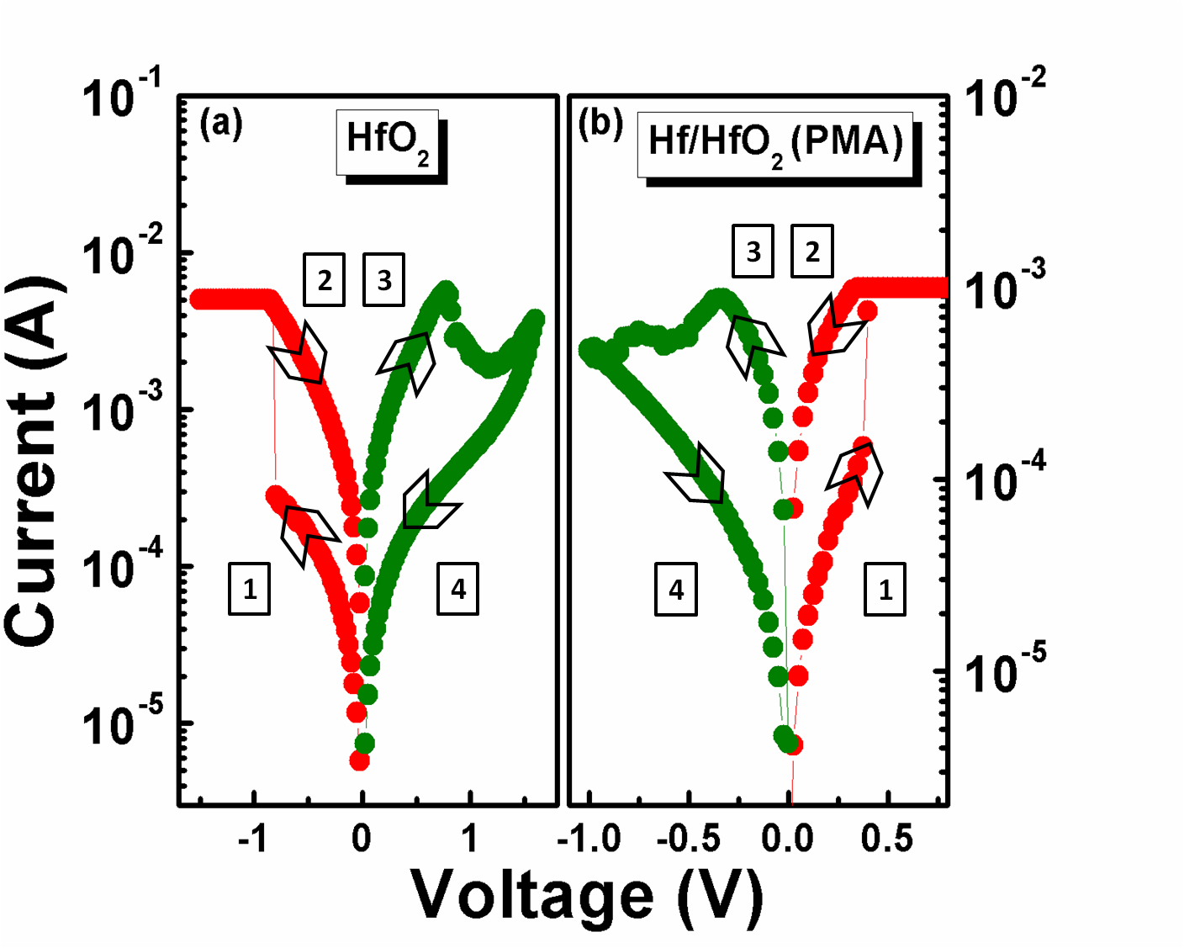
Figure 1. Peng et al.
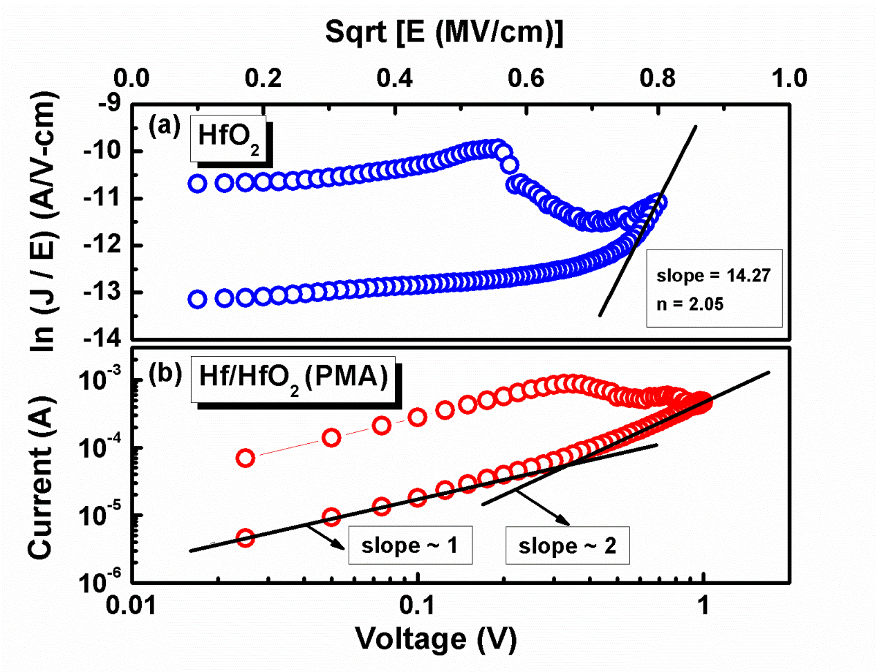
Figure 2. Peng et al.

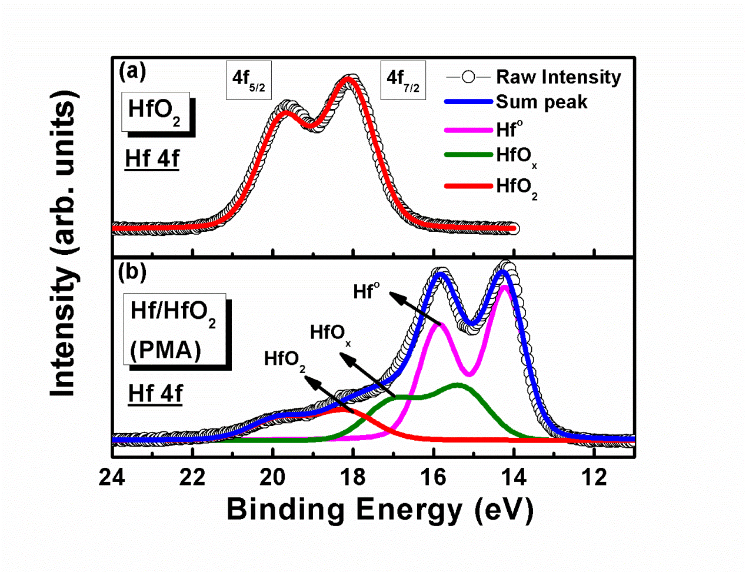
Figure 3. Peng et al
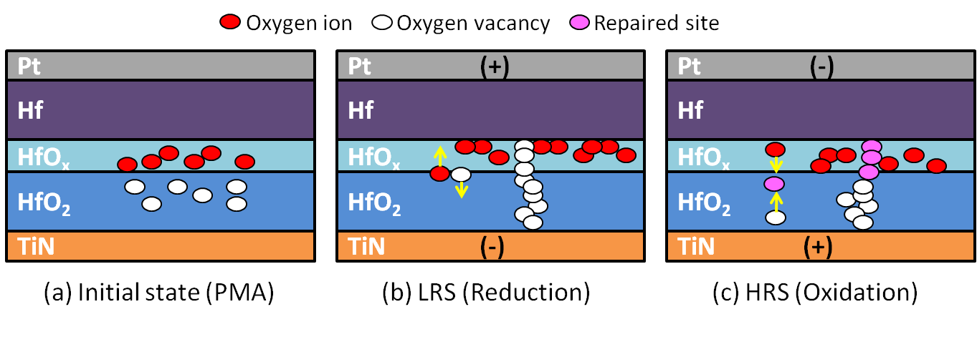
Figure 4. Peng et al
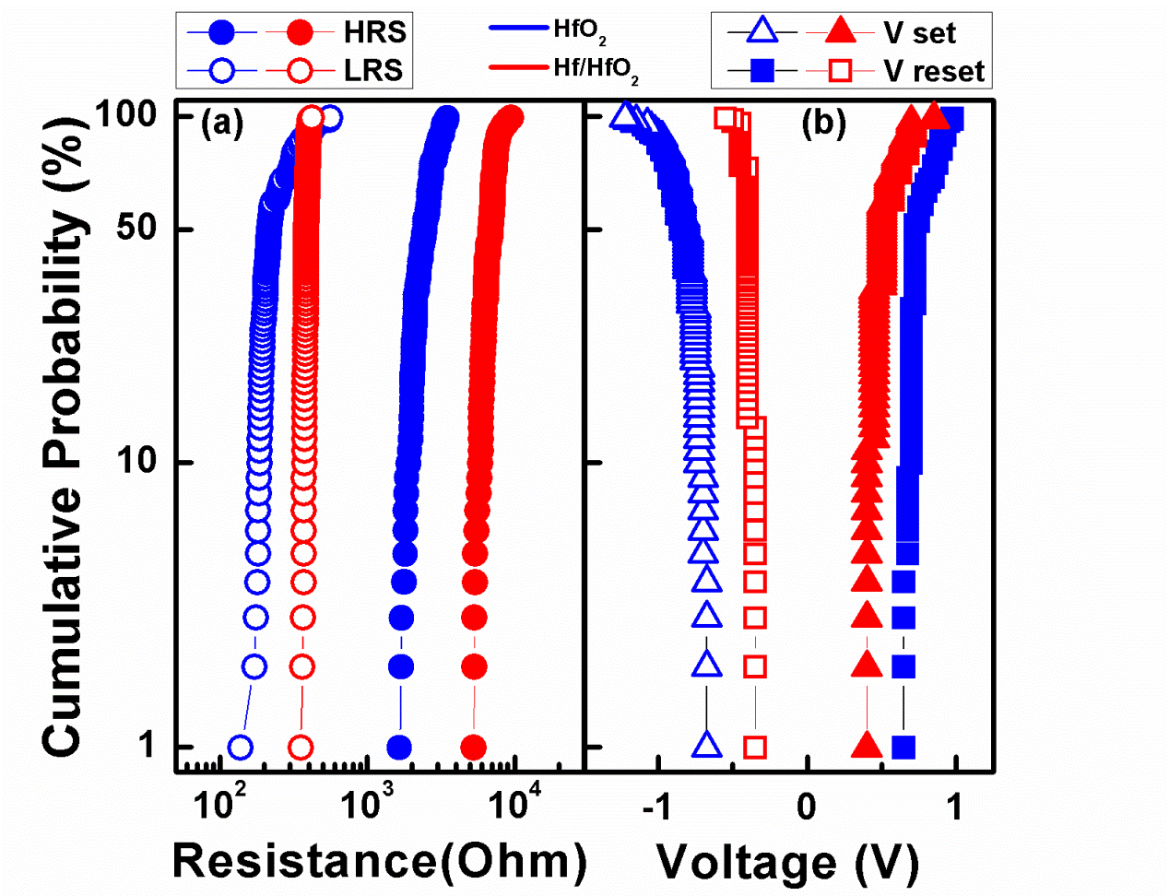
Figure 5. Peng et al.
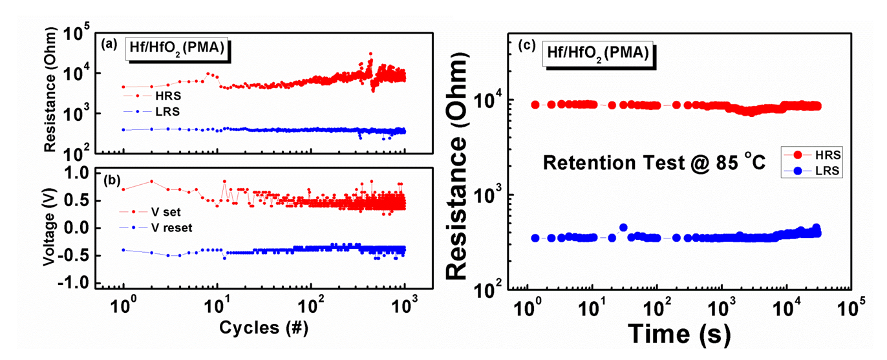
Figure 6. Peng et al.

GRAPHICAL ABSTRACT
Title: Cxxxxxx Trxxxxt Axxxxof Dixxxx InAs/GaAs QssssDosssst Structures
Authors: Hsss Hsss Sorrr, Jxxx Sxxx Kim, Xx Kxx Kim, Sxx Jxx Lee, and Sxx Kxx Nxx

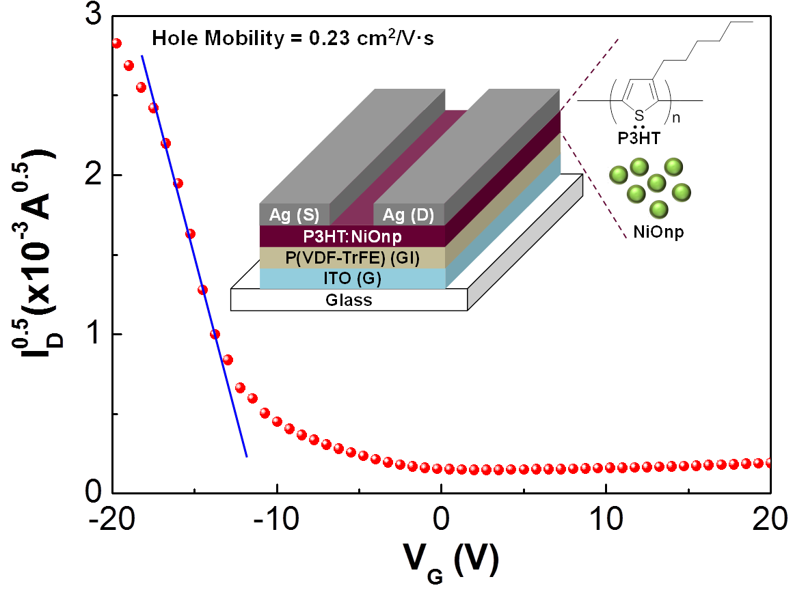
The energy states of InAs/GaAs self-assembled quantum dots (QDs) were analyzed by comparing between two QD systems with different QD sizes. The electrical properties of the QD systems were investigated via capacitance-voltage measurements and capacitancetransient spectroscopy (also known as deep-level transient spectroscopy) with selective carrier injection and extraction, which can be achieved with a very small pulse amplitude under bias variation. The comparison of the large QD structure with the small one was particularly focused on.

